Automated Smart Door Lock Using Arduino

Shreyash Hubale

ADYPSOE, Pune, Maharashtra, India, shreyash.hubale@dypic.in

ABSTRACT

This research paper presents the design, implementation, and evaluation of a smart door lock system that integrates Arduino microcontroller, Radio Frequency Identification (RFID) technology, and motor-driven locking mechanisms. Traditional door locking systems are being modernized to provide enhanced security, convenience, and accessibility. By leveraging Arduino's programmability, RFID's contactless identification, and motor-driven locking mechanisms, the proposed system offers a robust and efficient solution for access control.

- INTRODUCTION
The rising need for advanced access control solutions has catalyzed the evolution of cutting-edge door locking systems. Conventional lock-and-key setups are steadily making way for electronic alternatives, which boast enhanced security features, heightened convenience, and unparalleled flexibility. Within this realm, the fusion of Arduino microcontroller technology, RFID (Radio Frequency Identification) systems, and motordriven locking mechanisms emerges as a compelling avenue for revolutionizing door security. By harnessing the capabilities of Arduino microcontrollers, these innovative door locking systems gain a versatile and customizable platform for control and automation. Arduino's open-source nature allows for seamless integration with a wide array of sensors, actuators, and communication modules, enabling the creation of tailored solutions to suit diverse security requirements. The incorporation of RFID technology further fortifies the security aspect, offering swift and contactless authentication processes. RFID tags or cards, when paired with compatible readers, facilitate seamless access control, eliminating the need for physical keys and mitigating the risks associated with traditional key-based systems, such as unauthorized duplication or loss.

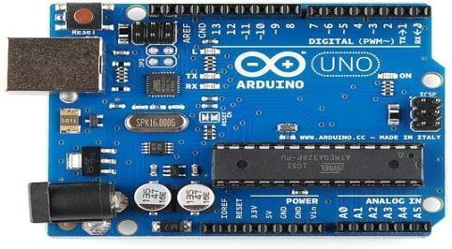
- WORKING
Initialization: Upon startup, the Arduino initializes its pins and any connected modules. RFID Authentication: When a user presents an RFID tag or card to the reader, the Arduino reads the unique identifier associated with it. Access Control Logic: The Arduino compares the received RFID identifier with a pre-defined list of authorized IDs stored in its memory. If a match is found, it proceeds to unlock the door; otherwise, it denies access. Lock Control: If access is granted, the Arduino sends a signal to the servo motor or solenoid lock to actuate the locking mechanism, either locking or unlocking the door. Feedback Mechanism: LEDs or a buzzer provide feedback to the user, indicating whether the door has been successfully unlocked or if there's an error in the authentication process. Timeout and Security Features: To enhance security, the system may include features such as automatic re-locking after a certain period of time or multiple failed authentication attempts.

Fig. Ardiuno uno

- BLOCK DIAGRAM
Connections between components are typically made using wires or cables, and the Arduino Uno facilitates communication between the various modules through its input/output pins. Additionally, the Arduino runs the software program that controls the overall operation of the smart door lock, including authentication, lock control, and user feedback.

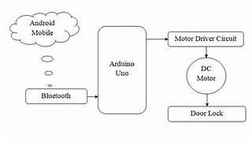

Fig.block diagram

IV.COMPONENTS & REQUIREMENTS

- ARDUINO UNO

Arduino board is an open source platform used for
,
building electronics projects. Arduino is a
programmable circuit’s board which we can write a
program based on your projects. Arduino program
will be uploading with IDE (Integrated
Development Environment) software that runs on
your computer, it is used to write and upload
computer code to the Arduino physical board.
Arduino language is merely a set of C/C++ functions
that can be called from your code.

- RFID READER

This component reads the RFID tags or cards presented by users for authentication. It typically communicates with the Arduino Uno through one of its digital input/output pins, using a communication protocol like SPI or UART. The Arduino then processes the data received from the RFID reader to determine whether to grant access or not.
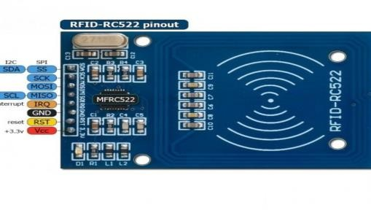

Fig. Rfid reader

- I2C MODULE

This module enables communication between different components using the I2C (Inter- Integrated Circuit) protocol. It acts as an interface between the Arduino Uno and other devices, such as the RFID reader and additional peripherals. The I2C module typically connects to the Arduino Uno via its dedicated I2C pins (SDA and SCL), allowing for efficient and synchronized data exchange between multiple components in the system.

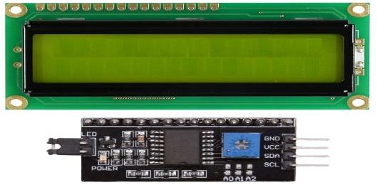

fig. I2C module

- SERVER MOTOR
This component controls the physical locking mechanism of the door. The servo motor receives control signals from the Arduino Uno and adjusts its position accordingly to lock or unlock the door. It typically connects to one of the Arduino's PWM (Pulse Width Modulation) pins, allowing for precise control over its rotation angle.
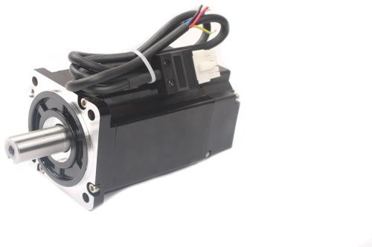

Fig. server motor

- CIRCUIT DIAGRAM
The circuit for the smart door lock system involves connecting various components to the Arduino Uno board. The RFID reader is linked to the Arduino, with its VCC pin connected to the Arduino's 5V output, GND pin to the Arduino's ground, and TX pin to a digital pin on the Arduino. An I2C module facilitates communication between devices, requiring its VCC and GND pins to connect to the Arduino's 5V output and ground, respectively, while its SDA and SCL pins connect to the Arduino's A4 (SDA) and A5 (SCL) pins. A servo motor, responsible for the physical locking mechanism, connects its power and ground pins to the Arduino's 5V and ground, respectively, and its signal pin to a PWM pin on the Arduino. Additionally, feedback mechanisms like LEDs or a buzzer connect to digital pins on the Arduino. Finally, the entire circuit is powered by a power supply or battery connected to the Arduino's power input. It's essential to ensure the correct pin configurations and follow safety protocols during the connections.

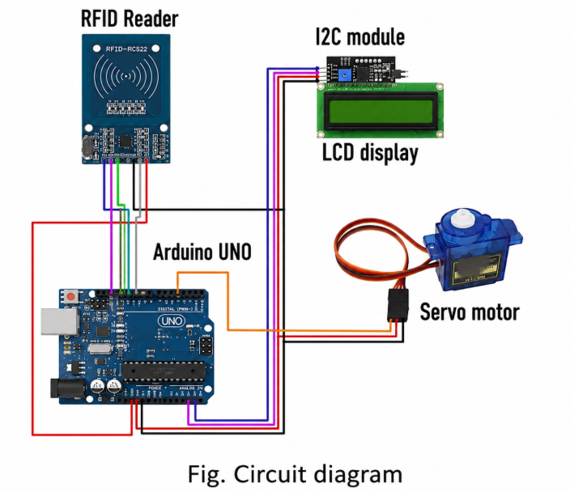

V.CONCLUSION

In conclusion, the integration of Arduino, RFID, and motor-driven locking mechanisms offers a versatile and effective solution for smart door lock systems. The developed system provides enhanced security, convenience, and accessibility compared to traditional lock-and-
key mechanisms. Future research directions may include further optimization of system performance, integration with smart home automation systems, and exploration of advanced security features.

VI.REFERENCES

[1] Bonekeh Belidus Gweh (2016), "The Use of Electronic Code Locks for The Security of Homes and Properties" BSc thesis, Centria University of Applied Sciences, Finland.
[2] SafeAround, (2018), "World’s Safest Countries" Retrieved: October 23, 2018 Available at: https://safearound.com/danger- rankings/
[3] N.H. Ismail, Zarina Tukiran, and N.N. Shamsuddin, "Android- based Home Door Locks Application via Bluetooth for Disabled People", 2014 IEEE International Conference on Control System, Computing and Engineering, 28 - 30 November 2014, Penang, Malaysia.
[4] Alethea O Dell, (2016), "The Pros and Cons of Mobile Access Control" Retrieved: October 31, 2018 Available at: https://www.northlandcontrols.com/the-pros- and-cons-of-mobile-access-control/

